 | Year 12 Methods  Week 4 Quiz | $$\frac{}{15}$$

Name: __________________
1. | Find the gradient of the tangent of y = (2x – 3)³ at the point where x = 1. | 2
2. | 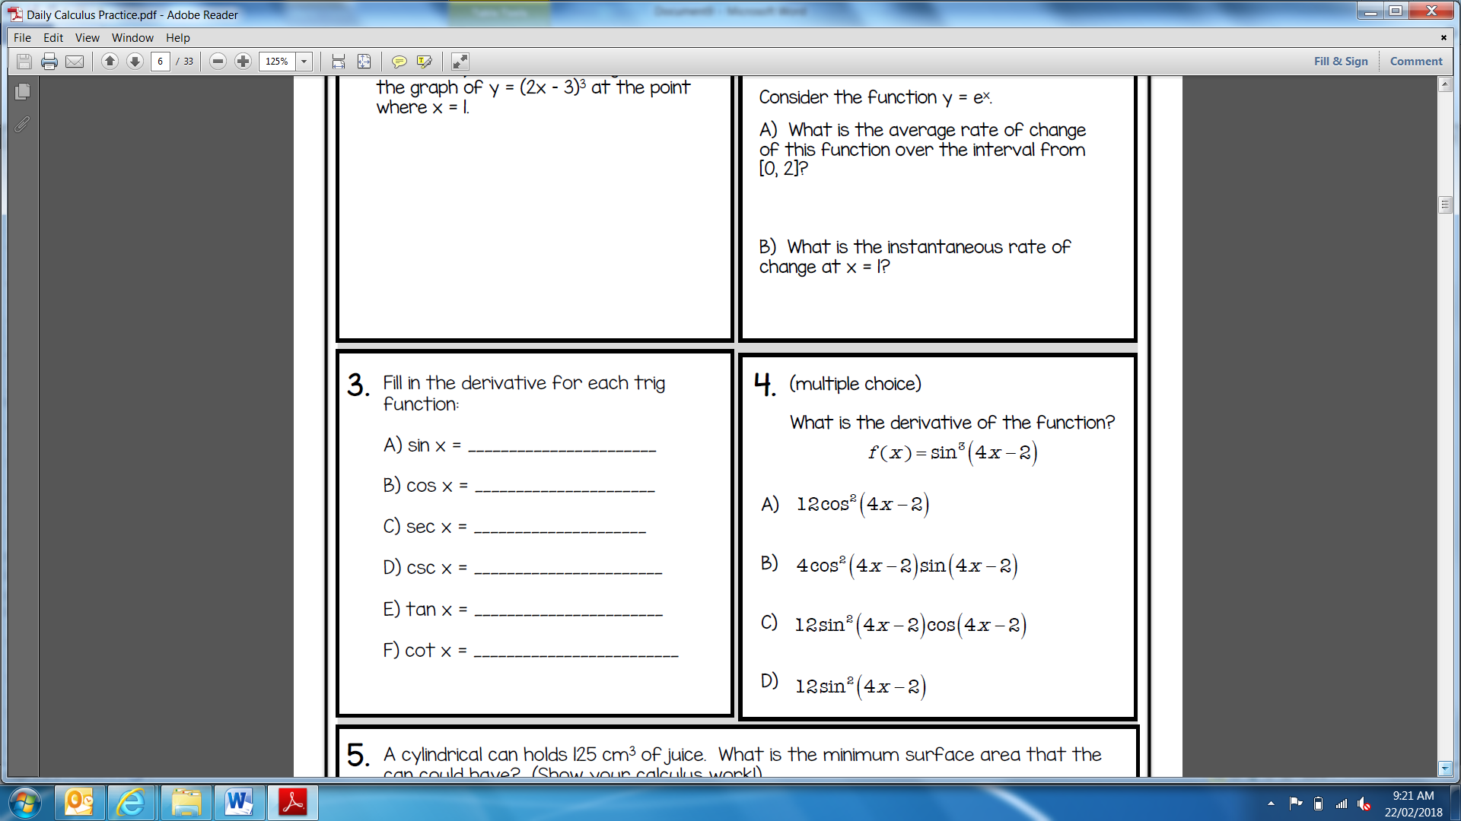 | 1
3. | 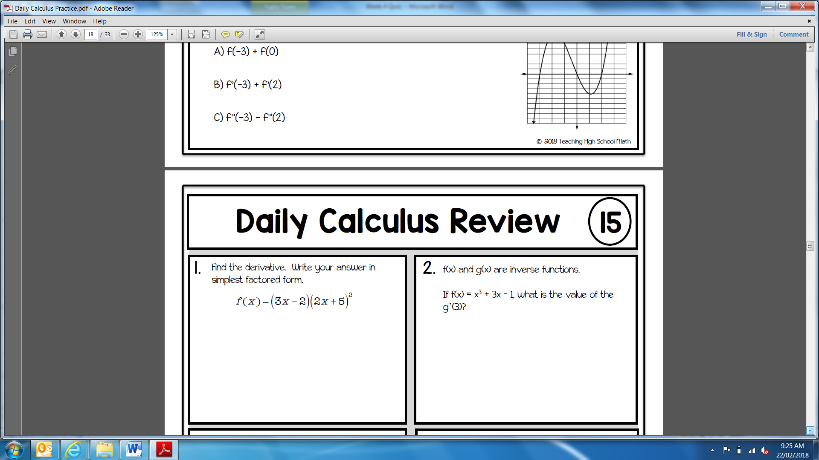   | 2
4. |   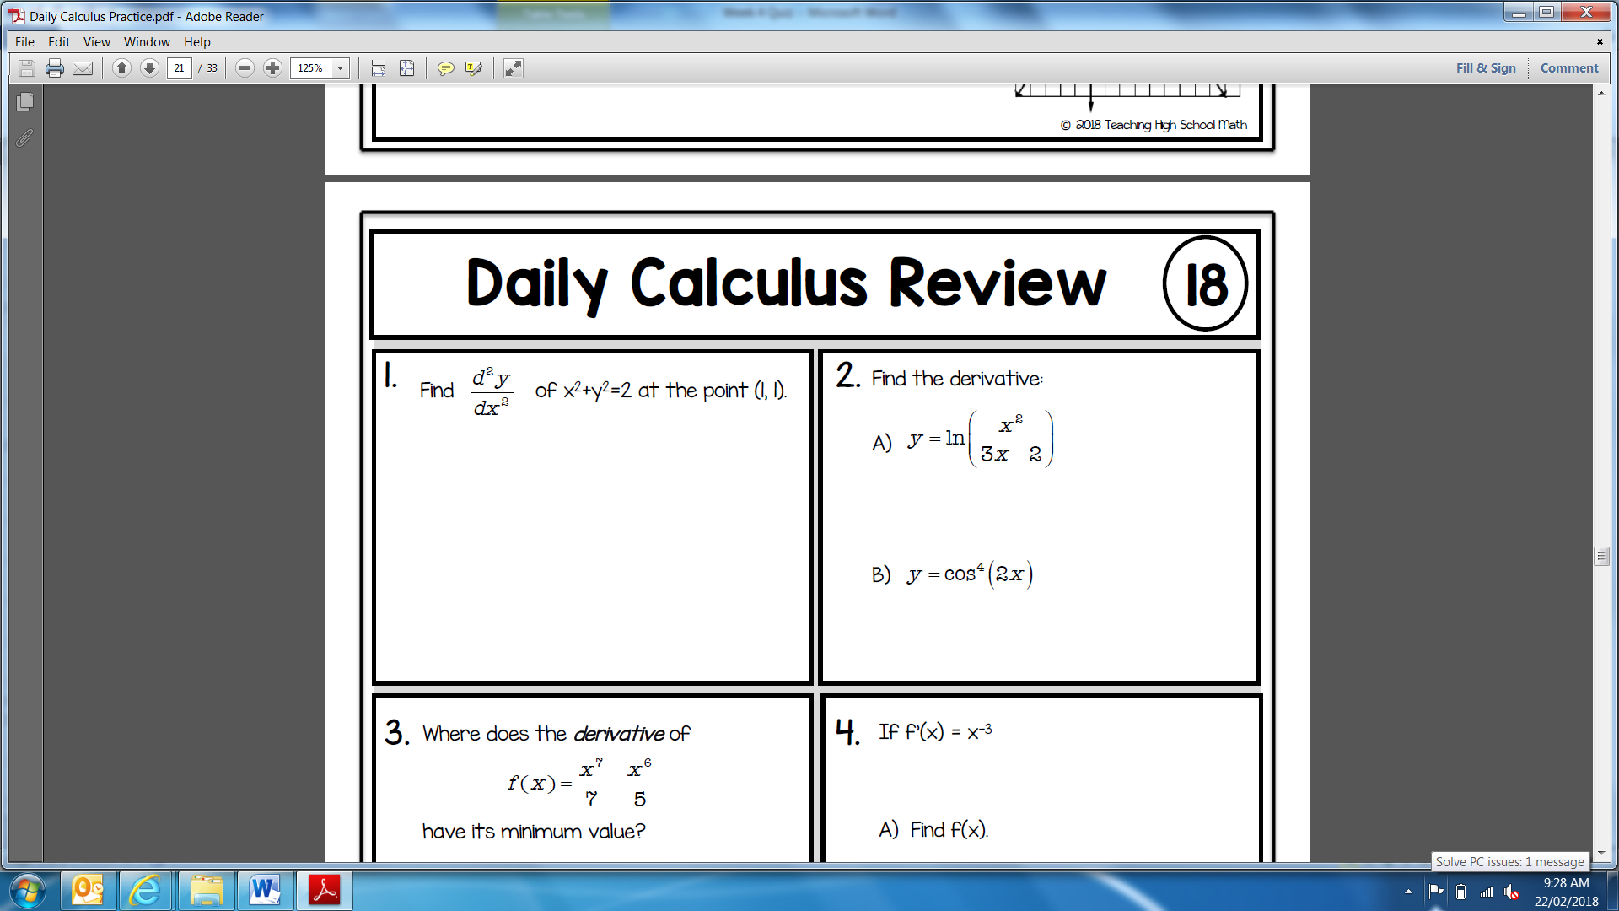 | 2
5. |   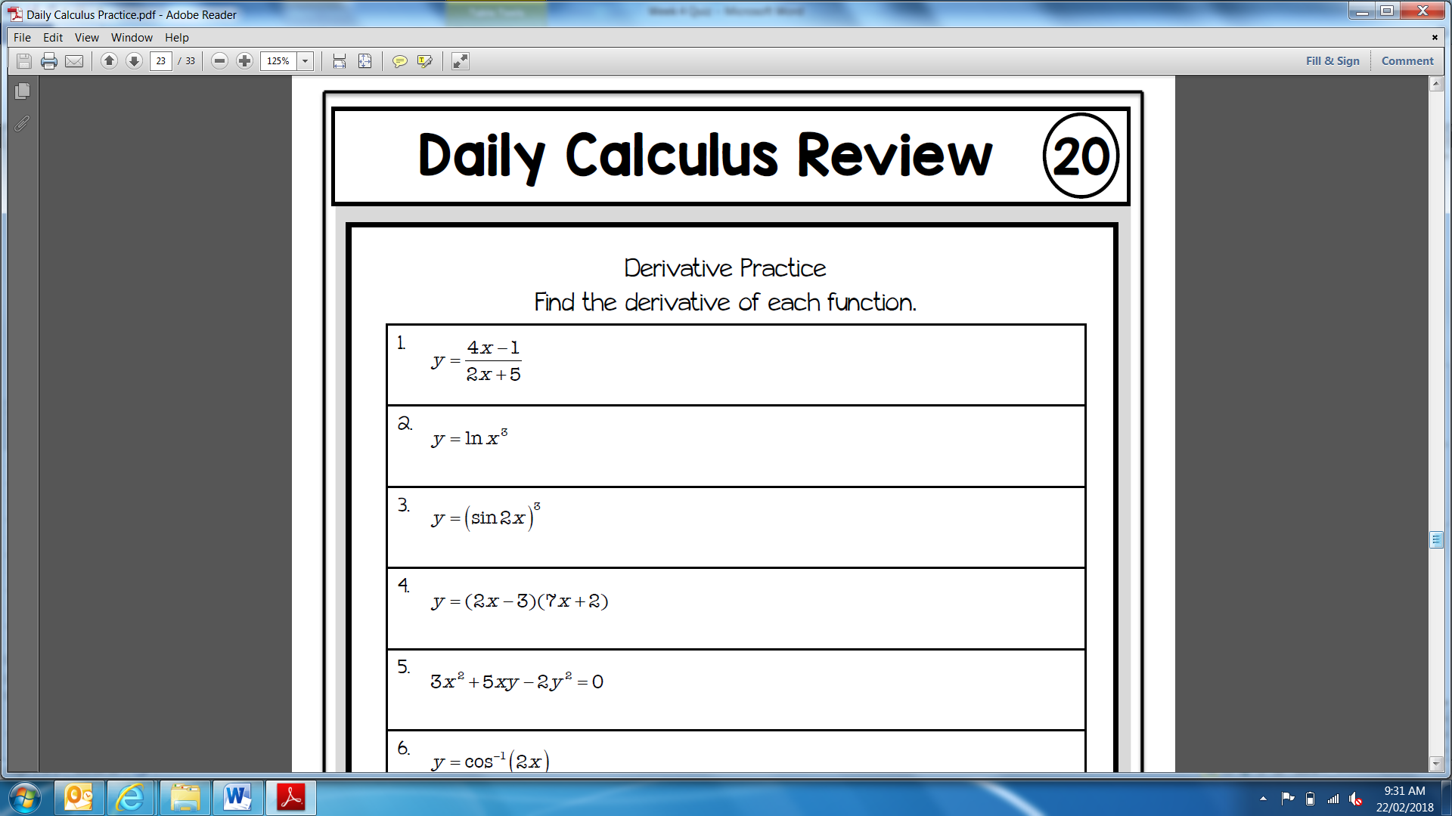 | 3
6. |    | 2
7. |    | 2
8. |   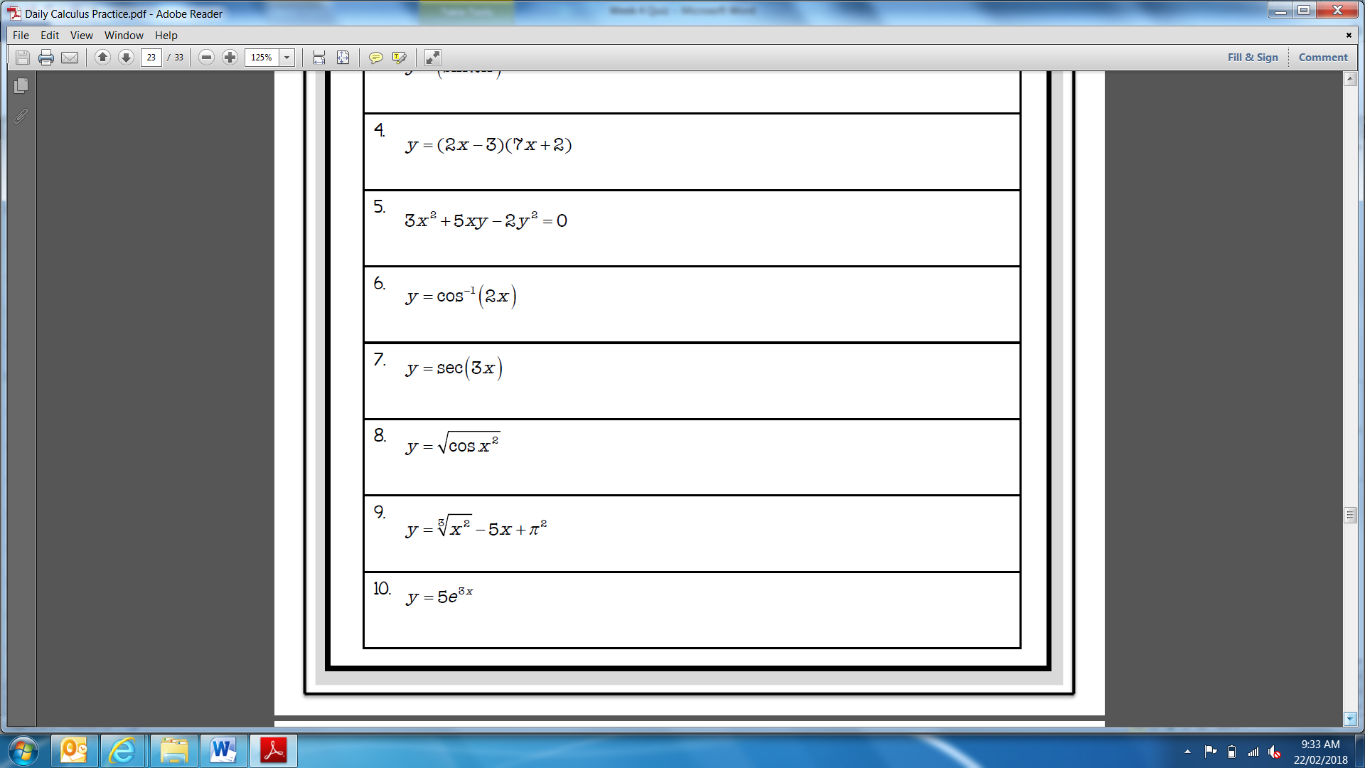 | 1

